FIT2097_A1

Link: <https://gitlab.com/yyeu0005/fit2097_a1.git>

Readme document, demonstration video and a copy of this document are pushed to the git (In the document file).

Program Design

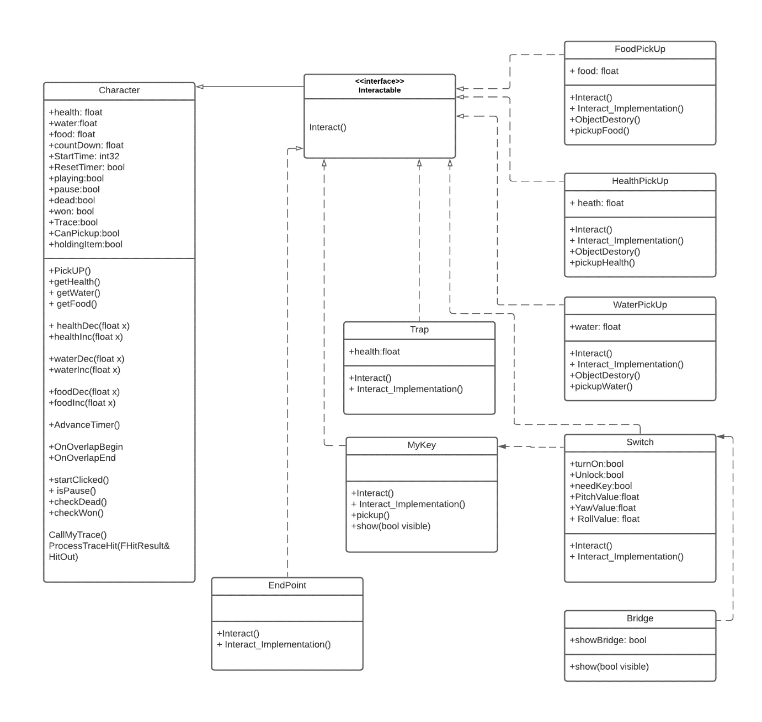

Character

This is the player class. This class manages the player’s health, food, and water level. Each of these variables has its own function for increase, decrease and get. I make those functions and the variable public to allow other classes, such as the Pickup class and the Trap class to get and make changes to those variables. The countdown, startTime, and reset timer variables are used to make the health, food, and water attributes drop every second. Those bool values: playing, pause, dead, and won are the status of the payer. The startClicked, isPause, checkDead and checkWon functions are created to check the player states and react. The CallMyTrace and ProcessTraceHit functions allow the player to interact with the interactable object. The CanPickup Boolean is created to ensure the player used Trace to interact with the object first before seeing the ‘how to interact’ message. The holdingItem Boolean is to check if the player picked up a key.

PickUp

The player can interact with these classes by walking into the pickup item. Character attribute should be recover when they walk into these pickup items. Thus, inside the Interact_Implementation function of each pickup class, I would use a pointer pointing to the character class and uses one of the functions: healthInc, foodInc, waterInc , in the character class, depends on the pickup’s type. The ObjectDestroy function is called after the item is ‘picked up ', the item would then get destroyed.

MyKey

The pickup function is being called in the Interact_Implementation function. There is a pointer pointing to the character class in the pickup function. It makes the Boolean, holdingItem turn to true, which means the player is having the key. The show function receives a visible Boolean, once the player picks up the key the make Boolean be false, and the key would become hidden in the game world.

Switch

There are Booleans turnOn, Unlock, and needKey in this class and their initial state is false. I would create a pointer that allows me to set a target(MyKey) for the switch in unreal. At the beginPlay the class would check if the switch has a key (MyKey) , if yes the needKey Boolean is true. In the Interact_Implementation function, it would first check the needKey Boolean. If false, the turnOn==true. If equals to true, the switch needs a key, it then cast to the player class and sees if the player holding a key. If true again turnOn==true. Else print a message to the screen tell the player to get a key. In the Tick, it prints the message of the unlocked switch to the screen and makes unlock =true. So, when the player clicks the switch again it could show the switch is activated massage.

Bridge

The showBridge Boolean is false at the beginning. The show (bool visible) is to determine the bridge is shown in the game. Also, I would set a pointer to make the bridge look at the switch class. In the beginPlay, it would search and target the switch. And in Tick it would check if the target is unlocked and if true, showBridge Boolean would change to true, and the bridge is shown.

Trap

This class has a health attribute of 100. There would be a pointer pointing to the character class in the Interact_Implementation function. When the player touches the trap, the function helathDec is called and their current health would reduce by 100 and would die instantly as the max health of a player is 100.

EndPoint

There is a pointer pointing to the character class in the Interact_Implementation function. When the player interacts with (walk into) this class, the checkWon function would be called and the player wins the game.